Airline Demand Forecasting
This Python program provides robust demand forecasts for airline bookings, given the flight departure date (departure_date) and the booking dates (booking_date). The program aims to optimize airline bookings forecast and minimize forecasting errors. The program uses historical flight bookings data (trainingDataFile) and estimates the final demand (final_demand) using the best of four mathematical models used in the program. The program uses naïve forecasting(naïve_forecast) data (validationDataFile), as a benchmark to select the best forecasting model. For this, the MASE (mean average scaled errors) of each forecasting model is compared with the MASE of the naïve forecasts. The program selects the best forecast model and uses that to forecast the final demand, for all the days up to the flight’s departure date.

We used “airline_booking_trainingData.csv” .csv file as input for trainingDataFile &“airline_booking_validationData_revised.csv” .csv file for the validationDataFile. We read these .csv files to create our training data frame train_dat and our validation data set valid_dat. For developing our forecast models, we have mutated the existing variables to create new variables. Foer example, we mutated days prior = departure date – booking date to create days_prior columns in train_dat as well as valid_dat. We also created a week_day column for which day of the week for the departure_date was taken. Likewise, created other variables required to be used in one or more of our forecast models. Table 1 given below provides a brief snapshot of the four forecasting models that we developed in our program. All the models used the same datasets for training and the same dataset for validation. All the models predicted final_demand for a given departure_date and booking_date. The program worked out the MASE error for each of the four models.
Table 1. Forecasting models used in the program
MODELS | LOGIC USED | VARIABLES USED | FORECASTING FORMULA =
Model_A | Multiplicative | days_prior,week_day | cum_booking/(average_booking_Rate)
Model_B | Multiplicative | days_prior | cum_booking/(average_booking_Rate)
Model_C | Additive | days_prior,week_day | cum_booking+average_remaining_demand
Model_D | OLS Regression | days_prior,week_day,cum_bookings | predict(final_demand)
Model_A is a multiplicative model and uses days_prior and week_day as inputs to work out an average_booking_rate for data grouped by unique combinations of days_prior and week_day. Dividing the cum_bookings by average_booking_rate provided us the demand forecast. Model_B was developed with the similar logic however, it used only the days_prior variable as an input. Model_C is an additive model and adds the average_remaining_demand to the cum_bookings, for the final_demand forecast. Model_D is using an OLS regression model to estimate the final_demand as dependent variable and days_prior, week_day, cum_bookings as independent variables. The predicted final_demand values from the model are used as forecast.

For all these models, we calculated the Mean Absolute Scaled Error (MASE). Our program selects the model having the lowest MASE value. Once a model is selected, our program returns the summary information on all the model, and a forecast data frame having departure_date, booking_date, and robust_forecast as its variables. The program also writes the output forecast data frame to a .csv file viz. “airline_robust_forecastData.csv” file.

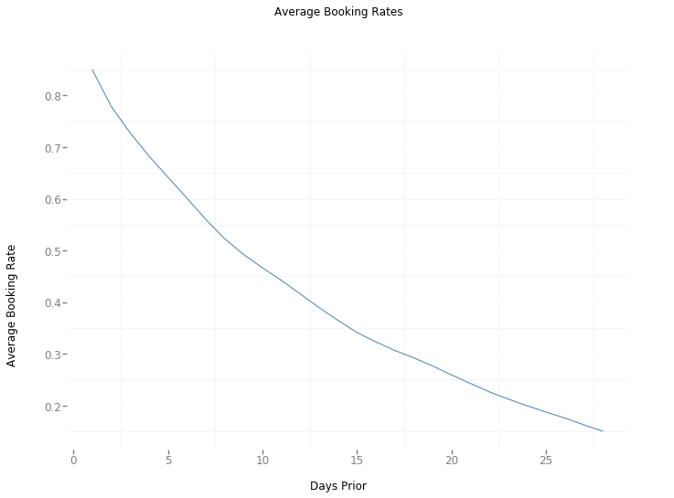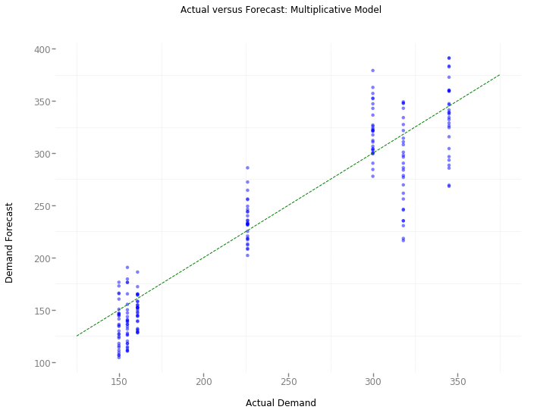

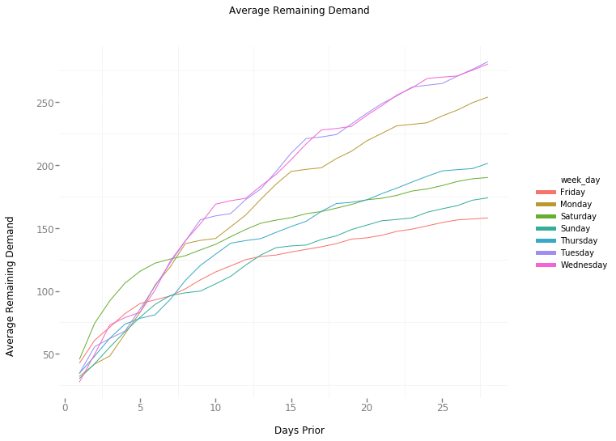
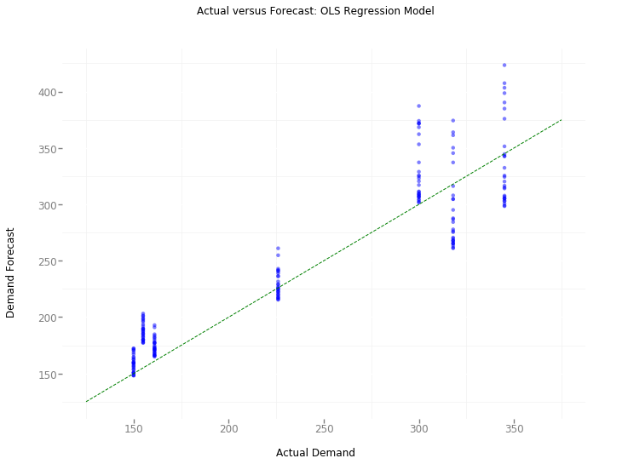

 | MASE | Improvement Over Benchmark
Multiplicative | 0.8298 | 17.02%
Additive | 0.7861 | 21.39%
OLS Regression | 0.8042 | 19.58%

Additive model performs best with 21.39% improvement over the benchmark errors.

-By Toulik Das
B.tech(CSCE)

